**Report for Nick Eubank**

**Analysis**

**Pre-post and Difference-in-difference analysis**

The project hypothesis is that the average annual percent change in per capita opioid quantities sold and overdose deaths is lower in the states where regulations were implemented when compared against the same jurisdiction prior to implementation and against jurisdictions where no new policies were implemented. To analyze this change, both a "Pre-Post Comparison" and "Difference-in-Difference Comparison" analysis will be utilized. To analyze the validity of the hypothesis, it is expected that the hypothesis is reasonable if the average annual percent change in per capita opioid quantities sold and opioid-drug-overdose deaths should be substantially less after the policies were placed than before the polices were introduced for each jurisdiction. Otherwise, the hypothesis will be rejected if the opioid-drug-overdose deaths per capita or the opioid quantities sold per capita continue to increase or basically keep constant after the regulation policy change.

For the three states (Florida, Washington, and Texas) that introduced opioid regulation policies, we choose three states as comparison states for them because they have similar population sizes and opioid dispense rates. The control states for Florida are Pennsylvania (PA), Ohio (OH), and Georgia (GA), the control states for Washington are Arizona (AZ), Maryland (MD), and Wisconsin (WI), the control states for Texas are Illinois (IL), New York (NY), and Virginia (VA). These control states did not implement policies to regulate opioid drugs, so we assume that an increase in opioid-drug-overdose deaths per capita or opioid quantities sold per capita is due to the state did not introduce policies to regulate opioid drugs.

**Effect of regulation policy on opioid shipments**

**Effect of regulations policy on the mortality rate of opioid-drug overdose**

**Florida** 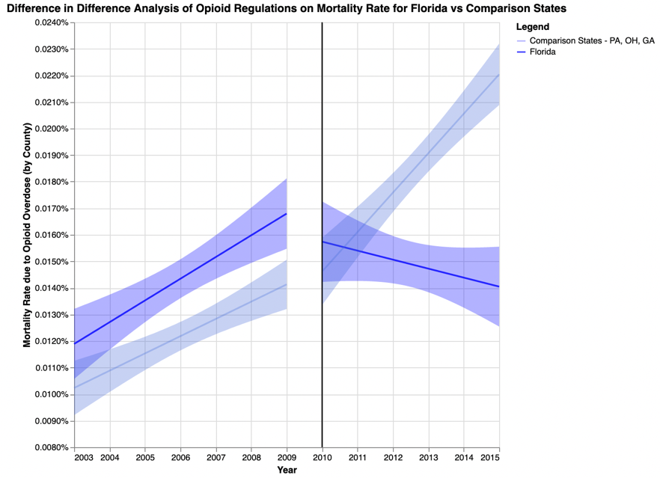

*Figure 1: Chart of the mortality rate of opioid-drug overdose between the pre-policy and post-policy periods, the regulation policy was effective in Florida in February 2010.*

After Florida implement the regulation policy for opioid drugs in 2020, it is obvious that the mortality rate of opioid-drug overdose has a decreasing tendency based on the left graph. Also, the right graph indicates the comparison between FL and its control states (PA, OH, GA) without implementing policies. It is evident that the mortality rate of opioid-drug overdose in these control states continues to hold an increasing trend after 2010. Based on the left graph, without implementing the regulation policy for opioid drugs, the average mortality rate of opioid-drug overdose had a rising trend from 0.012% year by year since 2003 and peaked at about 0.017% in 2009. After Florida implemented the regulation policy for opioid drugs in 2010, the mortality rate of opioid-drug overdose in FL dropped immediately to about 0.016% in 2010 and it continued to keep a downward tendency from 2010. This might not happen if the regulation policy was not implemented. Moreover, according to difference-in-difference analysis, the average mortality rate of opioid-drug overdose for the three comparison states was lower than the average mortality rate of Florida from 2003 to 2009 while all of them held increasing tendencies of the mortality rate of opioid-drug overdose. However, the three comparison states still had an upward trend of mortality rate after 2010, this tendency is the same as before 2010. In general, the mortality rate in control states increased from about 0.015% in 2010 to about 0.022% in 2015, while the mortality rate of opioid-drug overdose in Florida decreased from 2010 at about 0.016% to about 0.014% in 2015. Therefore, we conclude that the policy of opioid regulations had a positive impact on decreasing the mortality rate of opioid-drug overdose in Florida.

**Texas**

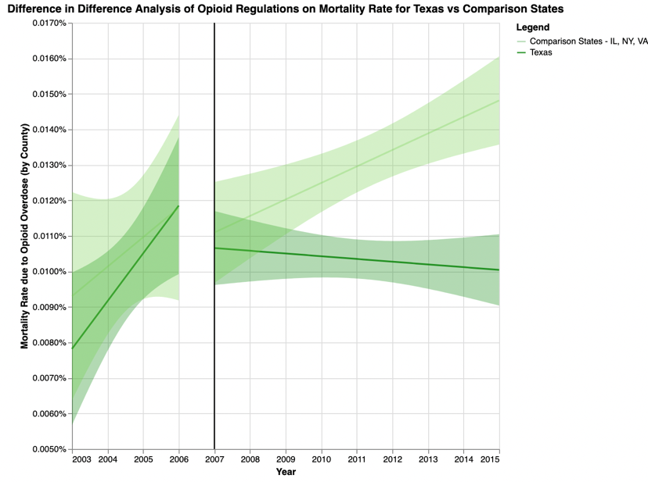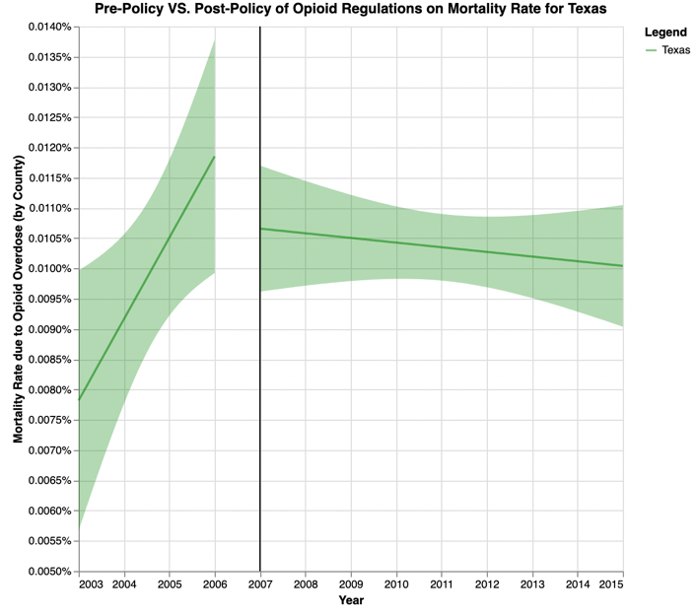*Figure 2: Chart of the mortality rate of opioid-drug overdose between the pre-policy and post-policy periods, the regulation policy was effective in Texas in January 2007.*

After Texas implement the regulation policy for opioid drugs in 2007, it is obvious that the mortality rate of opioid-drug overdose has a relatively decreasing tendency based on the left graph. Also, the right graph indicates the comparison between TX and its control states (IL, NY, VA) without implementing policies. It is obvious that the mortality rate of opioid-drug overdose in these control states continues to hold an increasing trend after 2007. Based on the left graph, without implementing the regulation policy for opioid drugs, the average mortality rate of opioid-drug overdose had an increasing trend from about 0.008% year by year since 2003 and peaked at about 0.012% in 2006. After implementing the regulation policy for opioid drugs in 2007 at TX, the mortality rate of opioid-drug overdose in TX dropped immediately to about 0.0105% in 2007 and it continued to keep a downward tendency from 2007. This might not happen if the regulation policy was not implemented. Moreover, according to difference-in-difference analysis, the average mortality rate for the three comparison states had similar values as the average mortality rate of Texas from 2003 to 2006 while all of them held increasing tendencies of the mortality rate of opioid-drug overdose. Nevertheless, the three comparison states still had an upward trend of mortality rate after 2007, this tendency is the same as before 2007. In general, the mortality rate in control states increased from about 0.011% in 2007 to about 0.015% in 2015, while the mortality rate of opioid-drug overdose in Texas decreased from 2007 at about 0.011% to about 0.010% in 2015. Therefore, although such a degree of decline is not large, we conclude that the policy of opioid regulations had a positive impact on decreasing the mortality rate of opioid-drug overdose in Texas.

**Washington**

*Figure 3: Chart of the mortality rate of opioid-drug overdose between the pre-policy and post-policy periods, the regulation policy was effective in Washington in January 2012.*

After Washington implement the regulation policy for opioid drugs in 2012, the mortality rate of opioid-drug overdose still had a decreasing, but lesser degree tendency based on the left graph. Also, the right graph indicates the comparison between WA and its control states (AZ, MD, WI) without implementing policies. It is obvious that the mortality rate of opioid-drug overdose in these control states continues to hold an increasing trend after 2007. Based on the left graph, without implementing the regulation policy for opioid drugs, the average mortality rate of opioid-drug overdose had an increasing trend from about 0.0125% year by year since 2003 and peaked at about 0.0145% in 2011. However, after implementing the regulation policy for opioid drugs in 2012 at WA, the mortality rate of opioid-drug overdose in WA did not drop, it continued to keep an upward, but lesser degree tendency from 2012. Furthermore, according to difference-in-difference analysis, the average mortality rate for the three comparison states were lower than the average mortality rate of Washington from 2003 to 2011 while all of them held increasing tendencies of the mortality rate of opioid-drug overdose. The three comparison states still had an upward trend of mortality rate after 2012, this tendency is the same as before 2007. In general, the mortality rate in control states increased from about 0.015% in 2012 to about 0.017% in 2015, and the mortality rate of opioid-drug overdose in Washington also rose from 2012 at about 0.0138% to about 0.014% in 2015. Therefore, although the mortality rates of opioid-drug overdose in Washington were lower than other control states on average after implementing the policy; because Washington still had a rising trend of mortality rates of opioid-drug overdose after 2012, we conclude that the policy of opioid regulations did not have a positive impact on decreasing the mortality rate of opioid-drug overdose in Washington.